Math 226 Review for Test 2
- An urn contains two blue balls (denoted 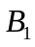and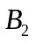) and one white ball (denoted  ).
One ball is drawn, its color is recorded, and it is replaced in the urn. Then another ball is drawn, and its color is recorded.

- Let denote the outcomes that the first ball drawn is and the second ball drawn is . Because the first ball is replaced before the second ball is drawn, the outcomes of the experiment are equally likely. List all nine possible outcomes of the experiment.
- Consider the event that the two balls that are drawn are both blue. List all outcomes in the event. What is the probability of the event?
- Consider the event that the two balls that are drawn are of different colors. List all outcomes in the event. What is the probabilityof the event?
2) Suppose that in a certain state, all automobile license plates have four letters followed by three digits.
- How many different license plates are possible?
- How many license plates could begin with A and end in 0?
- How many license plates could begin with TGIF?
- Prove the following statement:
There are integers and such that 1 and 1 and 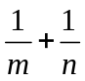 is an integer.
- Prove the statement by mathematical induction:
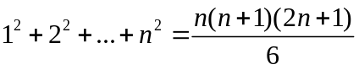, for all integers 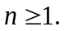
Determine whether the property is true for all integers, true for no integers, or true for some integers and false for other integers. Justify your answers.
- The average of any two odd integers is odd .
- For all integers 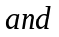, if 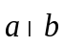 then 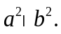
- a. How many 16-bit strings contain exactly seven 1’s?
b. How many 16-bit strings contain at least thirteen 1’s?
c. How many 16-bit strings contain at least one 1?
d. How many 16-bit strings contain at most one 1?
- Prove the following statement: The sum of any three consecutive integers is divisible by 3. (Two integers are CONSECUTIVE if, and only if, one is one more than the other)
- Prove that for all integers 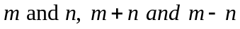 are either both odd or
both even.
- Prove that for all integers 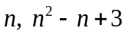is odd.
- When an integer is divided by 7, the remainder is 4. What is the
remainder when 5 is divided by 7?
- a. Use the quotient-remainder theorem with 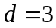 to prove that the product of any three consecutive integers is divisible by 3.
b. Use the notation to rewrite the result of part (a).
12) Prove each of the statement by mathematical induction.
1), for all integers
- For any integers 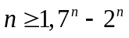 is divisible by 5.
- Every student in discrete math class is either a computer science major, a math major, or a dual major. How many students are in the class if there are 38 computer science majors, 23 math majors, and 7 dual majors?

